ECONOMICS FIELD STUDY PROGRAM
University of California, Santa Cruz

*Field study credit is open only to UCSC economics, global economics, business management economics, economics combined majors or M.S. in applied economics & finance students.
*Undergraduates must have successfully completed ECON 100A, 100B, and 113.
*Field study credit is limited to juniors, seniors, and master-level students.
*Students who apply for Field Study must be in good academic standing.

Application for Field Study

For (Check One): SUMMER FALL WINTER SPRING YEAR: ________

Name: _____________________________________________ Date: ________________

UCSC Email Address: _____________________________________________________

Student ID: _____________________

College: _______________________Current Address: ___________________________

City/State/Zip: ___________________________________________________________

Phone: ________________________

Class Level: ____________________

Major: ______________________

If you are not a U.S. citizen or a perm. resident, please state your visa status__________________

Acceptance into the program will be determined by your responses to the questions on the back of this form, your resume, and your academic standing.

The Economics Field Study Program has permission to review my academic file to substantiate my preparation for field study.

*If accepted, I agree to check my UCSC email WEEKLY.

______________________________________
Your signature

TURN OVER ⇒
Steps to Apply:
The following must be included with your application (your application will be considered incomplete if instructions are not followed):

- Please answer the following questions on a typed page (limit 2 pages).

- What are your career interests?

- What do you hope to gain from doing a field study?

- What coursework do you hope to build on?

- What types of field study positions are you hoping to explore?

- Attach your resume to this application.
For resume assistance, please visit the Career Center website: http://careers.ucsc.edu/student/resumecoverltr/index.html

- Please email completed applications to the program coordinator at econintern@ucsc.edu by the end of Week 7 of the quarter prior to your field study.
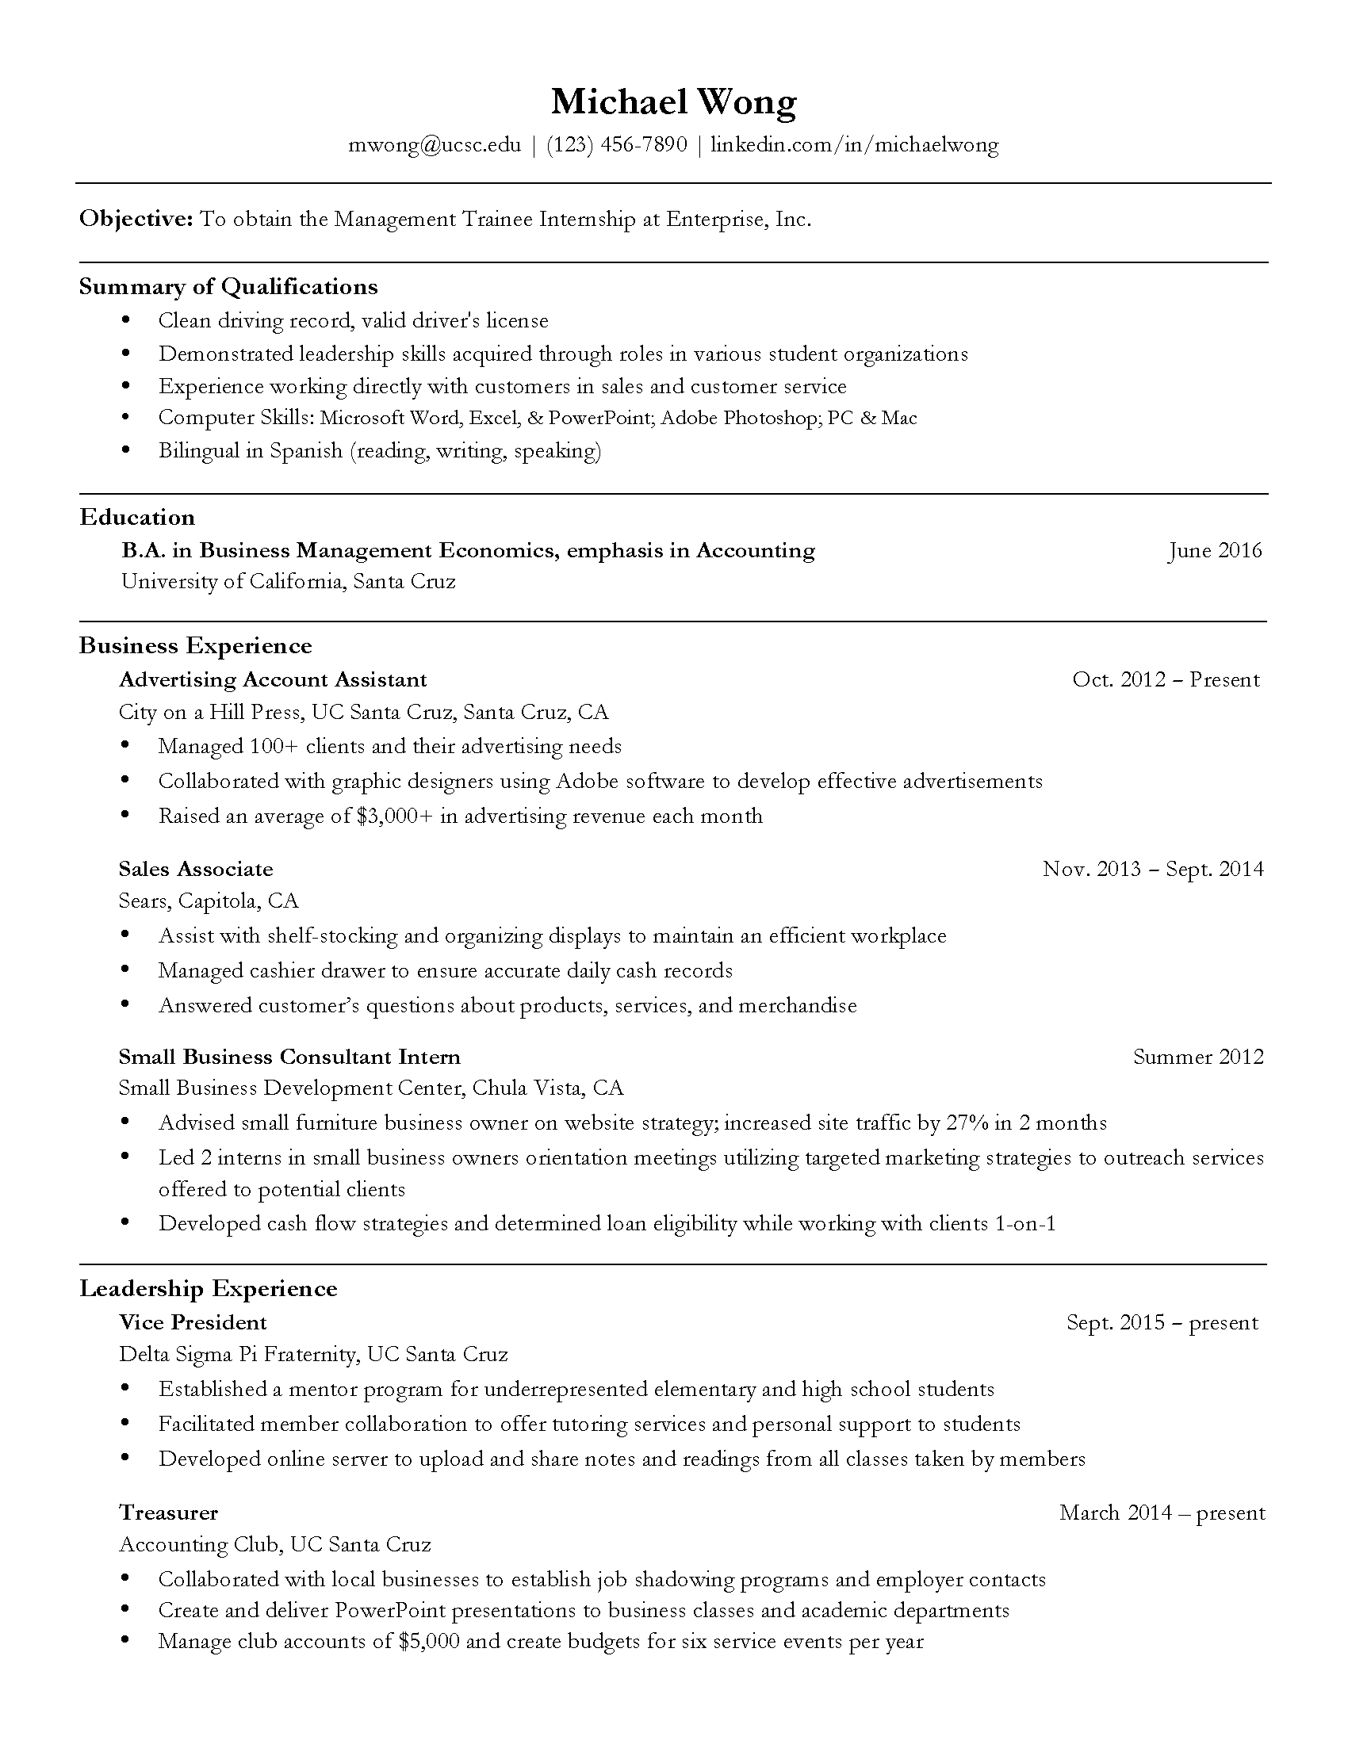
Include the following in your resume:

- Your Name: Bold and size 11-13 font. The rest of the resume should be 11-12 font.
- Contact Information: Professional appropriate email, phone number, address, and LinkedIn URL (optional).
- Education: List the degrees(s) you are working towards, associate degrees from community colleges (if you are a transfer student), and any study abroad programs you have participated in.
- Summary of Qualifications: Use 3-5 bullet points to list strengths applicable to the job description (include computer or language skills in a bullet point list).
- Relevant Coursework: Courses you have taken that are relevant to the position you are applying for.
- Work Experience: Begin with your most recent work experience. You can include volunteer experience and organizations/clubs as well!

